**BANK MANAGEMENT SYSTEM**

A PROJECT REPORT

BY

Dhruv (E23CSEU1031)

Divyansh Jain (E23CSEU1042)

Parth Azad (E23CSEU1032)

SUBMITTED TO

SCHOOL OF COMPUTER SCIENCE ENGINEERING AND TECHNOLOGY, BENNETT UNIVERSITY

GREATER NOIDA, 201310, UTTAR PRADESH, INDIA

April 2024

# DECLARATION

We hereby declare that the work which is being presented in the report entitled “BANK MANAGEMENT SYSTEM”, is an authentic record of our own work carried out during the period from JAN, 2024 to April, 2024 at School of Computer Science and Engineering and Technology, Bennett University Greater Noida.

The matters and the results presented in this report has not been submitted by us for the award of any other degree elsewhere.

Signature of Candidate

Dhruv

(Enroll. No. E23CSEU1031)

Divyansh Jain

(Enroll. No. E23CSEU1042)

Parth Azad

(Enroll. No. E23CSEU1032)

# 

**TABLE OF CONTENTS**

<<Right click on the heading and click update flied. Your heading will be pulled here. Same goes with all the table of content in the subsequent pages>>

LIST OF FIGURES iv

PROBLEM STATEMENT v

1. INTRODUCTION 1

1.1. Problem Description 2

2. PROJECT OUTLINE 3

3. IMPLEMENTATION BACKGROUND 4

4. PROJECT DOCUMENTATION 5

ONLINE RESOURCES 10

LIST OF FIGURES

**Figure** **Page**

Login Page 5

Sign Up Pages 6

Deposit 7

Cash Withdrawal 7

Fast Cash Withdrawal 8

Balance Enquiry 8

Mini Statement 9

Pin Change 9

PROBLEM STATEMENT

The “Bank Account Management System” project is a model Internet Banking Site. This site enables the customers to perform the basic banking transactions by sitting at their office or at homes through PC or laptop. The system provides the access to the customer to create an account, deposit/withdraw the cash from his account, also to view reports of all accounts present. The customers can access the banks website for viewing their Account details and perform the transactions on account as per their requirements. With Internet Banking, the brick and mortar structure of the traditional banking gets converted into a click and portal model, thereby giving a concept of virtual banking a real shape. Thus, today's banking is no longer confined to branches. E-banking facilitates banking transactions by customers round the clock globally.

The primary aim of this “Bank Account Management System” is to provide an improved design methodology, which envisages the future expansion, and modification, which is necessary for a core sector like banking. This necessitates the design to be expandable and modifiable and so a modular approach is used in developing the application software. Anybody who is an Account holder in this bank can become a member of Bank Account Management System. He has to fill a form with his personal details and Account Number. Bank is the place where customers feel the sense of safety for their property. In the bank, customers deposit and withdraw their money. Transaction of money also is a part where customer takes shelter of the bank. Now to keep the belief and trust of customers, there is the positive need for management of the bank, which can handle all this with comfort and ease. Smooth and efficient management affects the satisfaction of the customers and staff members, indirectly. And of course, it encourages management committee in taking some needed decision for future enhancement of the bank. Now a day’s, managing a bank is tedious job up to certain limit. So software that reduces the work is essential. Also, today’s world is a genuine computer world and is getting faster and faster day-by-day. Thus, considering above necessities, the software for bank management has become necessary which would be useful in managing the bank more efficiently. All transactions are carried out online by transferring from accounts in the same Bank or international bank. The software is meant to overcome the drawbacks of the manual system

The Bank Account Management System is an application for maintaining a person's account in a bank. In this project we tried to show the working of a banking account system and cover the basic functionality of a Bank Account Management System. To develop a project for solving financial applications of a customer in banking environment in order to nurture the needs of an end banking user by providing various ways to perform banking tasks. Also, to enable the user’s work space to have additional functionalities which are not provided under a conventional banking project. The Bank Account Management System undertaken as a project is based on relevant technologies. The main aim of this project is to develop software for Bank Account Management System. This project has been developed to carry out the processes easily and quickly, which is not possible with the manuals systems, which are overcome by this software. This project is developed using Java language. Creating and managing requirements is a challenge of IT, systems and product development projects or indeed for any activity where you have to manage a contractual relationship. Organization need to effectively define and manage requirements to ensure they are meeting needs of the customer, while proving compliance and staying on the schedule and within budget. The impact of a poorly expressed requirement can bring a business out of compliance or even cause injury or death. Requirements definition and management is an activity that can deliver a high, fast return on investment. The project analyzes the system requirements and then comes up with the requirements specifications. It studies other related systems and then come up with system specifications. The system is then designed in accordance with specifications to satisfy the requirements. The system design is then implemented with Java. The system is designed as an interactive and content management system. The content management system deals with data entry, validation confirm and updating whiles the interactive system deals with system interaction with the administration and users. Thus, above features of this project will save transaction time and therefore increase the efficiency of the system The main aim of designing and developing this Internet banking System Java primarily based Engineering project is to provide secure and efficient net banking facilities to the banking customers over the internet. Apache Server Pages, MYSQL database used to develop this bank application where all banking customers can login through the secured web page by their account login id and password. Users will have all options and features in that application like get money from western union, money transfer to others, and send cash or money to inter banking as well as other banking customers by simply adding them as payees.

1. INTRODUCTION

Many of us lead busy lives. Some of us are up before the crack of dawn, getting ourselves prepared so we can in turn get our families ready for the day. We rush to work, rush to get the kids to school, and at the end of the day we rush home only to brace ourselves for the next day. After a hectic day, the last thing you want to do is spend time waiting in line at the bank, or even the post office. That's where Online Banking comes in. Many of the benefits of doing our banking online are obvious: 1- You don't have to wait in line. 2- You don't have to plan your day around the bank's hours. 3- You can look at your balance whenever you want, not just when you get a statement. There are some hidden benefits too. As a young bank customer, you're just learning how to manage your money and observe your spending patterns. Online banking allows you to watch your money on a daily basis if you want to. By keeping close tabs on your funds, you'll always be aware of what's happening in your bank account. For those experienced spenders, this option is far more appealing than the sudden discovery that you're broke! It's also helpful to watch how much interest you're gathering on investments and savings or what service charges you have incurred.

Problem Description

The Traditional way of maintaining details of a user in a bank was to enter the details and record them. Every time the user needs to perform some transactions he has to go to bank and perform the necessary actions, which may not be so feasible all the time. It may be a hard-hitting task for the users and the bankers too. The project gives real life understanding of Online Banking System and activities performed by various roles in the supply chain. Here, we provide automation for banking system through Internet. Online Banking System project captures activities performed by different roles in real life banking which provides enhanced techniques for maintaining the required information up-to-date, which results in efficiency. The project gives real life understanding of Online Banking System and activities performed by various roles in the supply chain

1. PROJECT OUTLINE

**Main Goal**

1. Motto: Our motto is to develop a software program for managing the entire bank process related to Administration accounts customer accounts and to keep each every track about their property and their various transaction processes efficiently. Hereby, our main objective is the customer’s satisfaction considering today’s faster in the world.

2. Customer Satisfaction: Client can do his operations comfortably without any risk or losing of his privacy. Our software will perform and fulfill all the tasks that any customer would desire.

3. Saving Customer Time: Client doesn't need to go to the bank to do small operation.

4. Protecting the Customer: It helps the customer to be satisfied and comfortable in his choices, this protection contains customer’s account, money and his privacy.

5. Transferring Money: Help client transferring money to/or another bank or country.

**Methods**

• We need to be able to generate an account number

• Account types: Savings or Current Account

• Maintain/update Balance

• Open/Close Account

• Withdraw/Deposit

A simple user can access their account and can deposit/withdraw money from their account. User can also transfer money from their account to any other bank account. User can see their transaction report and balance enquiry too.

1-User login, use PIN system

2- Creating/open new account registration

3- Funds transfer (local/international/domestic)

4- View statements transaction

5- User account details

6- Change Pin

1. IMPLEMENTATION BACKGROUND

In the Bank Management System project developed using Java basics, Java Swing, Java AWT, MySQL, and JDBC, here's an overview of the libraries and frameworks used:

Java Basics: This refers to the core Java programming language itself, including its syntax, data types, control structures, and object-oriented principles. Java provides the foundation for the entire project.

Java Swing: Java Swing is a GUI (Graphical User Interface) toolkit for Java. It provides a set of components for building desktop applications in Java. In the Bank Management System, Swing would be used to create the graphical user interface elements such as buttons, text fields, labels, and other widgets.

Java AWT (Abstract Window Toolkit): Java AWT is another GUI toolkit for Java, older than Swing. While Swing provides a richer set of components and is more flexible, AWT is still used in conjunction with Swing for certain functionalities or when compatibility with older systems is necessary.

MySQL: MySQL is a popular open-source relational database management system. It's used to store and manage the data related to the bank management system, such as customer information, account details, transactions, etc.

JDBC (Java Database Connectivity): JDBC is a Java API for connecting and executing queries on a database. It provides methods for querying and updating data in a database from Java programs. In the Bank Management System project, JDBC would be used to establish a connection with the MySQL database, execute SQL queries, and retrieve or modify data as needed.

Overall, the combination of Java basics, Swing, AWT, MySQL, and JDBC provides a robust foundation for developing a Bank Management System with a user-friendly graphical interface and efficient database management capabilities.

1. PROJECT DOCUMENTATION

* LOGIN FOR EXISTING USER
* OPEN NEW ACCOUNT FOR NEW USER
* GENERATE ACCOUNT NUMBER AND SET PIN
* CASH DEPOSIT/WITHDRAWAL , FAST CASH WITHDRAWAL
* BALANCE ENQUIRY, MINI STATEMENT
* PIN CHANGE

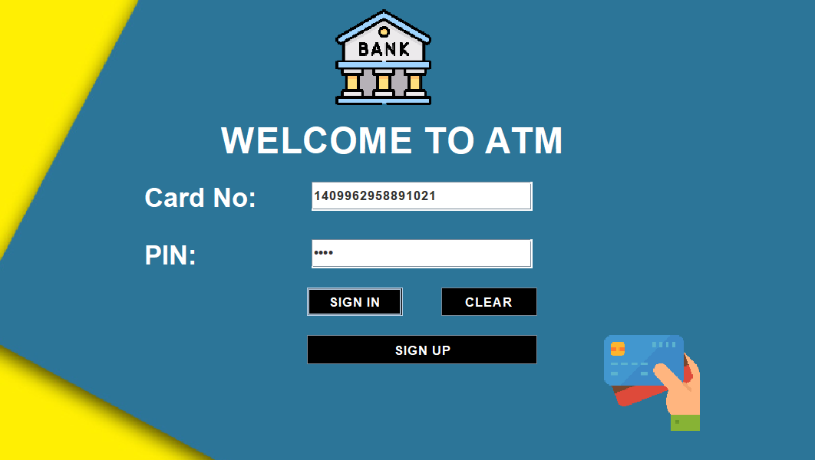

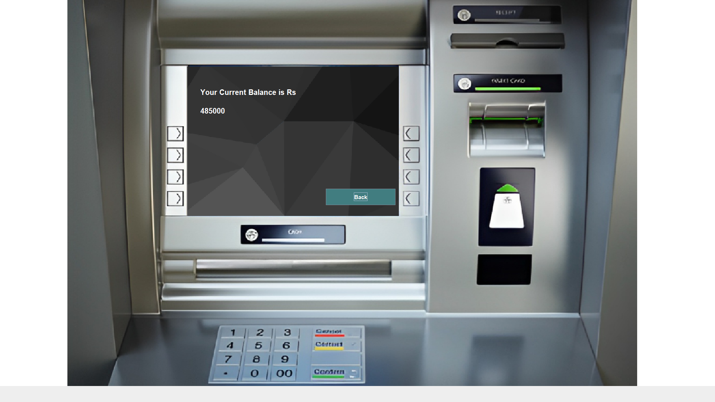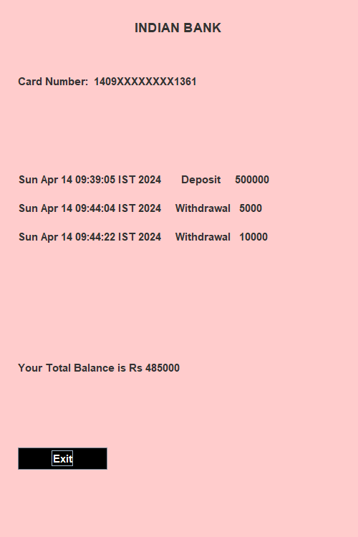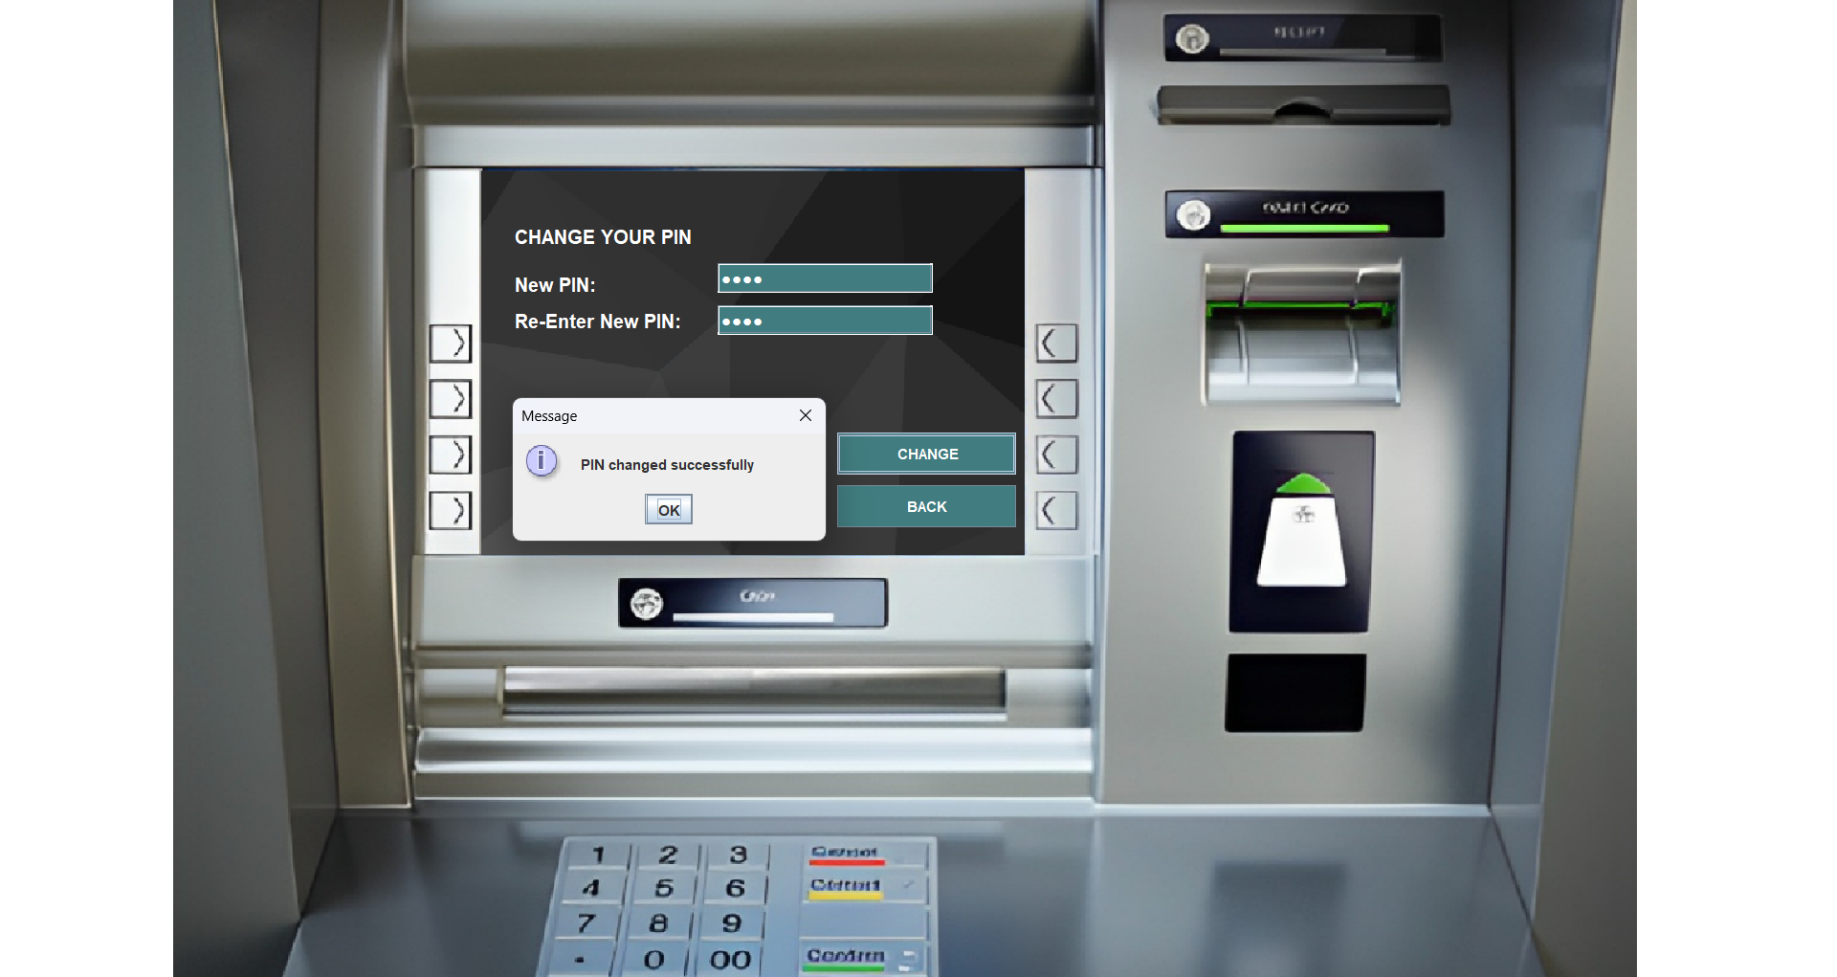

ONLINE RESOURCES

**Oracle Java Documentation:**

Website: [Oracle Java Documentation](https://docs.oracle.com/en/java/)

**Java Swing Tutorials:**

Website: [Java Swing Tutorials](https://docs.oracle.com/javase/tutorial/uiswing/)

Description: Oracle's official tutorials on Java Swing provide comprehensive guidance on building GUI applications using Swing components.

**MySQL Documentation:**

Website: [MySQL Documentation](https://dev.mysql.com/doc/)

Description: MySQL's official documentation offers extensive resources on installation, configuration, SQL syntax, and JDBC connectivity.

**JDBC Documentation:**

Website: [JDBC Documentation](https://docs.oracle.com/javase/8/docs/technotes/guides/jdbc/)

Description: Oracle's JDBC documentation provides tutorials and reference materials for connecting Java applications to databases using JDBC.